Somerleyton Road Basement – Invitation for Expressions of Interest

Background
Lambeth Council are seeking expressions of interest from organisations to bring forward an exciting opportunity in the basement of the new Ovalhouse Theatre in the Somerleyton Road development. The successful operator would enter into a lease agreement to run a workspace that contributes to the local creative economy.
This brief sets out:
- Context and further information about the opportunity
- The process and timescales.

Context and further information
Somerleyton Road
The Somerleyton Road development is a major regeneration scheme that will deliver over 300 homes (of which half will be affordable), new workspace, a theatre, community space, a children’s centre and retail units in the heart of Brixton.
Phase one of the scheme will see the construction of the new Ovalhouse Theatre building and the refurbishment of the historic Carlton Mansions, bringing over 3,000 square metres of workspace to the area. Located in the Brixton Creative Enterprise Zone, the site is a key opportunity for the council to act on its priorities to:
- Protect and grow creative production space;
- Develop creative clusters and networks;
- Support business development of creative organisations;
- Create enterprise employment and skills opportunities; and
- Build community links in socially inclusive spaces.
The theatre’s new four storey home includes an expansive basement of 1,097 square metres. The council are now seeking expressions of interest (EoIs) from organisations who would like to lease the basement space. We are seeking a tenant for the basement space that will add to the area’s creative cluster.
The site is less than five minutes’ walk from Brixton underground and rail stations and is well connected by bus links to other parts of London.
Construction has already commenced and is expected to be completed by January 2021. The space will be handed over shell and core, including WC facilities and a kitchen point, and has separate access from the main theatre entrance.
We anticipate granting a lease of at least 10 years for the basement space.

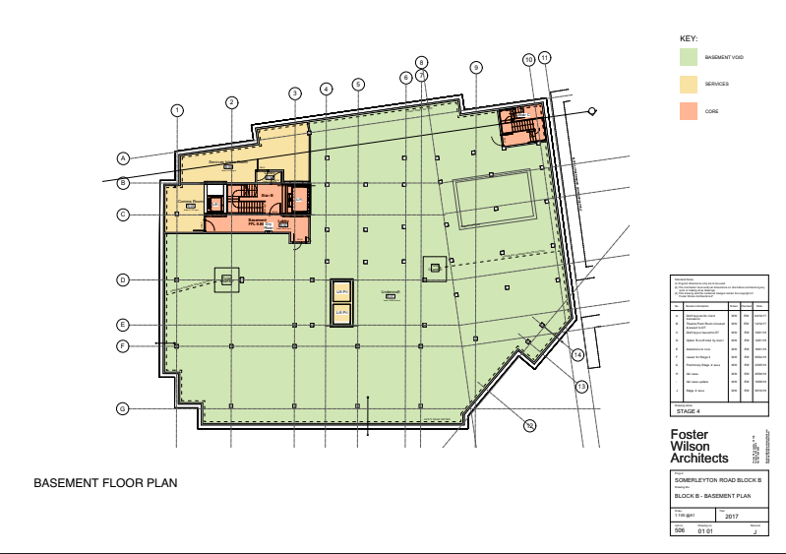
Basement plan

A full-size plan of the basement is provided at Appendix 3. Also appended is a section drawing of the building for information.

Strategic Context
Creative Ways to Grow
Lambeth’s Creative and Digital Industries (CDI) Growth Strategy sets out how the council and its partners can work together to develop CDI clusters in Lambeth’s growth areas, including Brixton.
Brixton already has a small but vibrant CDI cluster which has significant potential to grow and bring wider benefits for existing businesses and local residents. The existing CDI economy includes larger scale architecture and design practices (e.g. Squire and Partners and Martha Schwartz Partners), film and TV production companies (e.g. Jellyfish Studios), digital start-ups and social impact companies working to break down barriers for young people from disadvantaged backgrounds to enter into the CDI sector (e.g. Reprezent Radio; Photofusion; Raw Material). International House has recently opened and is home to businesses with a focus on tech and design (e.g. Resi, Gravity Sketch, Assemble’s Fabric Floor.)
A key component of the CDI strategy is to encourage the clustering of creative and cultural organisations to create a critical mass of talented workers and creators, access to clients, opportunities for collaboration, knowledge sharing and socialising.
The Somerleyton Road basement presents a unique opportunity to contribute to this diverse and vibrant mix.
Brixton CEZ
Creative Enterprise Zones are a bold new initiative for London to secure its future as a cultural capital and ensure creative people continue to call London their home. Lambeth was recently successful in their bid for a development grant to promote Brixton as a Creative Enterprise Zone. The funding will be used to employ a Creative Enterprise Manager in order to keep Brixton creative and grow the local business base through:
- New creative clusters and networks (e.g. outdoor artistic projects)
- Creative production (e.g. retaining and increasing workspace)
- Local policy (e.g. business rate relief where possible)
- Business development (e.g. tailored start up support)
- Enterprise and skills (e.g. creative careers advice consortium)
- Community links and socially inclusive places (e.g. affordable rents linked to social return).
Brixton
Brixton is recognised for its vibrancy and richly diverse cultural history. Brixton has a flourishing night time economy complemented by the variety of new and existing retail, food and drink, and entertainment businesses. In recent years Brixton has undergone rapid economic and social change. The Brixton Economic Action Plan (BEAP) responds to this and highlights that the area lacks the depth and range of workspaces to facilitate growth. It states that there is:

“Evidence of strong demand for flexible and affordable space suitable for small businesses/start-ups. Occupancy levels and take up levels within current workspace premises are reported to be high but the level of supply is constrained”.

It also highlights that Brixton:

- Creates some jobs and provides local services, but does not contribute as substantially as it could to the borough’s overall economic output and productivity; and,
- Should strive to meet and surpass the London average in key higher value sectors, given competitive advantages in terms of connectivity, skilled local workforce and other amenities such as a strong evening economy and food sector.

The BEAP recommends that the council should look to facilitate the provision of a range of workspaces (including affordable and incubator space) to ensure the economy continues to grow, and that job growth should focus on high value and high growth potential sectors including creative, digital, media, technology and social impact.

Expression of Interest Requirements
The council are seeking expressions of interest (using the form provided below) from potential tenants that bring innovative and creative ideas for use of the basement.
In this invitation for EoIs the council is intentionally non-prescriptive about ideas that could come forward. We are open to innovative and interesting uses of the space.
As this opportunity is in the basement of the new Ovalhouse Theatre building, the space will be subject to noise restrictions during performance and rehearsal hours. EoIs will need to be sensitive to this and acknowledge how any noise issues would be mitigated, e.g. through limited operating hours or by committing to sound proofing the space as part of fit out.
Please note that the basement also includes a small area (approx. 55 square metres) of restricted height below the theatre pit which would be suitable for storage.
The council are also keen to understand how proposals will add social value to the area, through community engagement and participation programmes in line with the Brixton Creative Enterprise Zone Action Plan (see Appendix 2) and Lambeth’s Creative & Digital Industries Strategy.
The council is seeking a rent for the space. Organisations will need to make clear in their EoI whether a financial contribution from the Council towards seed funding costs is being sought. If so, the EoI will need to detail the level of investment requested and how that investment would be spent. Price will be included in the evaluation of EoIs so the less seed funding required, the greater the score against price.
At this stage, the council has not estimated the potential business rates and service charge liability for the basement space. We encourage interested organisations to consider potential business rates and service charge levels in making an expression of interest.
The council will expect the tenant of the basement space to commit to being or becoming a Living Wage employer.

Process
Please complete the form overleaf and send completed EOIs including any images and appendices to invest@lambeth.gov.uk by 24 November 2019.
Where further information is required about an EOI, organisations will be contacted by 10 December 2019. We will then review any revised submissions and use these as a basis for further discussion with interested organisations from 10 January 2020.
Questions about the form or the opportunity should be directed to invest@lambeth.gov.uk.
Council officers within the Enterprise, Jobs and Skills and Homes for Lambeth divisions will be involved in scoring submitted EOIs.

Scoring EOIs
EOIs will be scored against the following criteria:
Criteria | Weighting
Alignment with strategic priorities and creative and cultural fit | 40%
Financial offer | 25%
Social value added | 25%
Experience and expertise in delivering similar projects | 10%

The council will evaluate EoIs’ responses against the above criteria through a scoring range of 0 to 5, where 0 is poor and 5 is excellent.

Alignment with strategic priorities and creative and cultural fit – 40%
Proposals should respond closely to the context and requirements set out in this brief, including consideration of the Brixton Economic Action Plan, the CDI growth strategy and the Brixton CEZ Action Plan when setting out intended use of the basement space. Proposals should demonstrate a good understanding of the common factors that typically underpin a successful creative and cultural cluster, giving consideration to the size and location of the space. Proposals should also demonstrate a good understanding of the local area and its resident and business communities, clearly showing how local people and business will benefit from the space.
Financial offer – 25%
Proposals may structure their financial offer as they decide. They should consider the requirement to pass the commercial tests, which means offering a rent appropriate to the proposed use and commercial viability of the overall development scheme. Applicants should provide detailed information about predicted income, expenditure and upfront costs and funding streams. The proposal should also include information on any requested investment in the start-up costs for the proposed project from the council e.g. for building modifications.
Social value added – 25%
Proposals should outline how the intended use of the basement will add to the vitality of Brixton through activity that is visible and accessible to the local community. Proposals should contribute to addressing social challenges around the barriers of accessing CDI, particularly for underrepresented groups (including people of colour, women and people with disabilities). Proposals should also consider how they may work with other organisations in the borough to create meaningful opportunities for local people, e.g. through publicly accessible and free/affordable activities and events (e.g. talks, workshops, practical classes).
Experience and expertise in delivering similar projects – 10%
The proposal should provide evidence of the organisation(s) and individuals involved in the proposal strong track record relevant to the proposal. This may be evidenced by case studies of projects relevant to the proposal.

Timescales
Timescales for this expression of interest are detailed below:
Output | Deadline
Opportunity advertised | 14 October 2019
EoIs submitted | 24 November 2019
EoIs reviewed | 8 December 2019
Follow up questions sent EoIs reviewed in phase 1 | 10 December 2019
Further information submitted | 20 December 2019
Further information reviewed | 6 January 2020
Notification of outcome | 10 January 2020

Appendices
Appendix 1: Expression of Interest Form
Appendix 2: Brixton Creative Enterprise Zone Action Plan
Appendix 3: Basement plan
Appendix 4: Block B section drawing
Appendix 1 - Expression of Interest Form
Please complete the following form and submit via email to invest@lambeth.gov.uk by 24 November 2019.
Organisation name: |  |  | Contact name:
Contact email: |  |  | Contact number:
Summary description of proposed use: |  | Max. 1,500 words.
Benefits to the local economy and alignment with local strategies and policies |  | Max. 1,000 words
Required planning use class |  | E.g. B1, D2
Proposed rent per sq. ft: |  | £
Further financial information |  | Max. 1,000 words
Proposed lease length:
Proposed hours of operation:
Details of specific requirements: |  | E.g. 24 hour access
Previous projects: |  | Please include links to information on previous work that demonstrates capacity to deliver on the proposals. This may be submitted as an appendix to this expression of interest.  Max. 1,000 words

Other Appendices

Appendix 2 – Brixton Creative Enterprise Zone Action Plan

Appendix 3 – Basement plan

Appendix 4 – Block B section drawing

