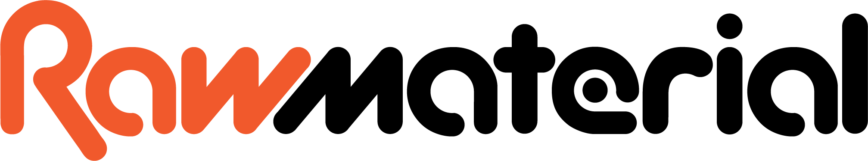

Hires and Events Officer - Elevate Internship

NB: This role is part of Lambeth’s Next Us programme, please check your eligibility before applying.

Dear applicant,

Thank you for your interest in joining us as our Hires and Events Officer.

To apply for the job, return the completed Equal Opportunities Form along with a short Covering Letter and CV explaining why you think you are suitable and what you would bring to the role by midday on 28th January. Online interviews will be taking place on the morning of 2nd February.

If you would prefer to make a video, instead of a covering letter, please include a YouTube link in your email. Please keep this to less than 3 minutes.

This role is supported through Lambeth Council’s Elevate Programme please check your eligibility and If you would like to know more or have any specific questions or concerns please contact Chinnelle McLean on cmclean1@lambeth.gov.uk

Please return your (maximum 2 page) covering letter (or youtube video link), CV and Equal Opportunities Form via email to recruitment@rawmusicmedia.org.

If you would like an informal chat about the job, please get in touch with Amy Taylor on amy@rawmusicmedia.org and I’ll be happy to answer any questions.

We look forward to receiving your application.
Deadline: 28th January

Hires and Events Officer - Elevate Internship
Job Description

Salary: LLW (£14.80ph)
Hours: 16 hours a week
Location: Brixton (Occasional work from home)
Managed by: Business Development Director

About Raw Material:
Raw Material is a Brixton-based creative arts and music centre for young people and adults, working in Lambeth, across London, the UK and internationally.
We believe that arts and music, delivered in a socially and culturally relevant way, have the power to positively change and shape people’s lives. Our base in Brixton houses recording studios, a live room and our brand new top floor ‘The Loft’ equipped for shows, events, rehearsals, yoga, dance and workshops.
Since reopening in February 2025 we have received a high demand for regular bookings, hires and events within our premises including hosting arts festivals, listening parties, Q+As, showcases and producing our own gigs and events. Our facilities are also regularly hired by artists and other professionals for meetings, workshops, rehearsals, photoshoots and hiring of our recording studios. Raw is also soon to launch its first ever artists in residency programme, supporting 5 different groups or individuals with their creative development throughout 2026 with the use of the building, our resources, co-working and showcases.
We are welcoming so many different people into our building each week and recognise the value in having a personal approach to those looking to use our facilities and resources, with this new role we’re looking for someone who can manage this varied workload, come up with new ideas of their own and be a welcoming face to our extended community.

Specific Duties:

- Managing all bookings and hires enquiries with prompt responses, ensuring those looking to use the space are offered any further resources they may need as well as high standard customer service.
- Keeping all booking systems up to date, ensuring the wider team have an oversight of the use of the building and handing over any set up instructions to any necessary members of staff.
- Contributing with new ideas for increasing and managing regular hires and events.
- Being the key point of contact for our Studio South Resident artists, supporting with enquiries, use of the space and any additional resources.
- Supporting the capture of useful information that demonstrates our impact as an organisation. I.e how many people are using the space / what for etc.
- Abiding by Raw Material’s values and responsibilities towards supporting the local and wider creative community.
- Other duties may occasionally be requested during events — as a small charity we all chip in to help each other out.
- Occasional onsite attendance at evening or weekend events when required (we operate a Time off In Lieu (TOIL) policy)

Person Specification - Essential
Candidates must be able to demonstrate:
- A good understanding and interest in the arts and creative industries.
- A creative approach to problem solving and a can-do attitude.
- Excellent organisational skills with great time management.
- Excellent communication skills, both written and verbal.
- Ability to work unsupervised and as part of a team.
- Good customer service skills - a personable and enthusiastic attitude
- A flexible attitude and willingness to attend the occasional event on weeknights and weekends if required

Next Us Internship Specific Criteria:
- Not currently in employment, education or training.

And can identify with any of the following:

- Living with ill mental health
- Neurodiverse (including Dyslexia and Dyspraxia) or SEND
- Care Experienced / Carer / Ex Carer / Childcare responsibilities
- Refugee
- Experience of substance misuse
- Currently or at risk of living homelessly

Desirable Skills Specification

- Understanding of GDPR / Safeguarding / Health and Safety Codes of conduct.
- Experience of working with a diverse community with varying needs.

We look forward to receiving your application.
Deadline: 28th January
recruitment@rawmusicmedia.org

